**High Level Diagram (Project X)**

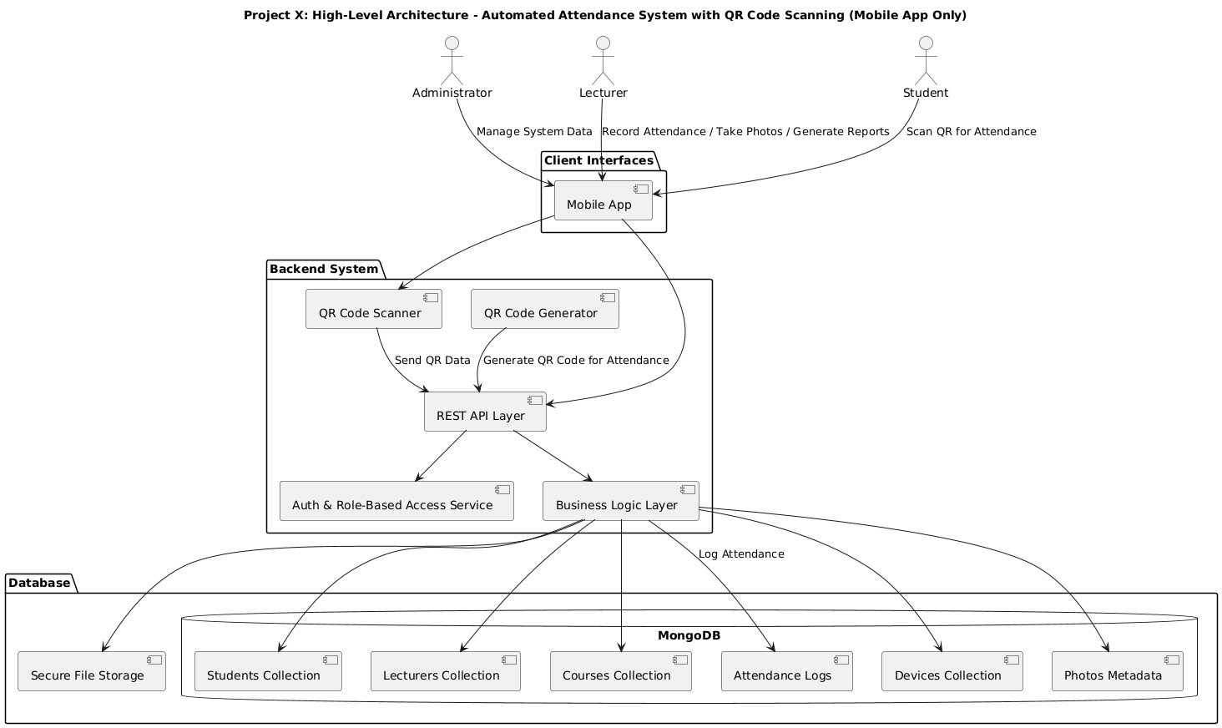

The Automated Attendance System (Project X) is designed to provide secure and efficient attendance tracking using a **mobile app** for both lecturers and students, with backend services supported by a **REST API** and **MongoDB** database.

#### Key Components:

**Users:**

* **Administrator:** Manages system data such as student records, lecturers, devices, and courses via the mobile app.
* **Lecturer:** Uses the mobile app to register attendance, capture student photos, generate attendance reports, and register devices.
* **Student:** Uses the mobile app to scan QR codes for marking attendance and to enroll in courses.

**Client Interface:**

* **Mobile App:** The single interface used by all users to interact with the system. Lecturers generate QR codes for attendance sessions and capture photos, while students scan these QR codes to record their attendance.

**Backend System:**

* **Authentication & Role-Based Access Service:** Ensures secure login and authorizes users based on their roles (Administrator, Lecturer, Student).
* **REST API Layer:** Acts as the communication bridge between the mobile app and backend services. All requests such as attendance recording, student enrollment, and report retrieval are processed here.
* **Business Logic Layer:** Implements core functionalities, including validating QR codes, managing attendance records, handling student and lecturer data, and enforcing access control.

**QR Code Components:**

* **QR Code Generator:** Allows lecturers to create unique QR codes for each attendance session. These codes encode session information such as course, date, and time.
* **QR Code Scanner:** Embedded in the mobile app for students to scan the lecturer-generated QR codes to mark their attendance securely.

**Database and Storage:**

* **MongoDB:** Stores collections for students, lecturers, courses, attendance logs, registered devices, and photo metadata.
* **Secure File Storage:** Stores student photos captured by lecturers securely and links them to student records.

#### System Workflow Summary:

1. A lecturer logs in through the mobile app and generates a QR code for the current attendance session.
2. Students use the mobile app to scan the QR code, which sends scanned data to the backend via the REST API.
3. The backend validates the QR code, verifies student enrollment, and records the attendance entry in MongoDB.
4. Administrators and lecturers can access reports and manage data through the mobile app.
5. The system enforces strict role-based access and device registration to ensure only authorized users and devices can record or modify attendance data.